**TASK 1**

package integers;

public class Integers {

public static void main(String[] args) {

int[]integer = {5,10,15,34,76,98};

for(int i=0; i<integer.length;i++)

System.out.println(integer[i]);

}

}

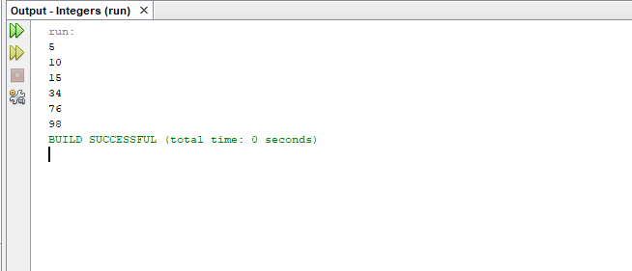

**Task 2**

package conditions;

public class Conditions {

public static void main(String[] args) {

int Number = -7;

if (Number >0){

System.out.println("The num is possitive");

}

else if(Number <0){

System.out.println("the number is negative");

}

}

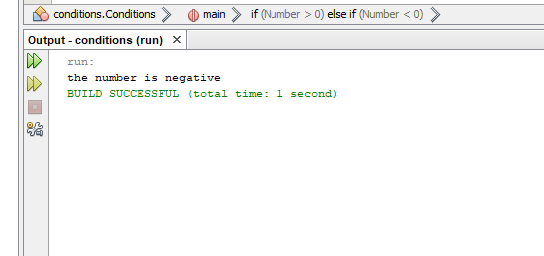

**Task 3**

package whileloop;

public class WhileLoop {

public static void main(String[] args) {

int number = 1;

while (number <=10){

System.out.println(number);

number++;

}

}

}

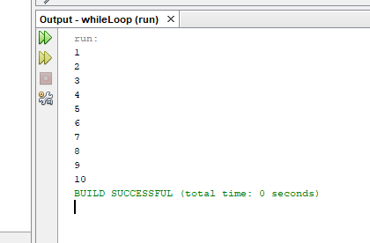

**Task 4**

package star;

public class Star {

public static void main(String[] args) {

int rows = 5;

for(int i=1; i<= rows; i++){

for(int j=1;j<=i;j++){

System.out.print("*");

}

System.out.println();

}

}

}

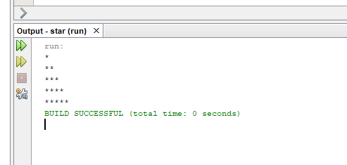

**Task 5**

package multiplication;

public class Multiplication {

public static void main(String[] args) {

int number =3;

for(int i=1;i<=10;i++){

System.out.println(number + "x" +i+ "="+(number*i));

}

}

}

